**Behavirol Questios:**

<https://www.youtube.com/watch?v=6pjGuuGsqxE>



**Improve write efficiency:**

* **Task-based thread pool:** We have divided complete workflow into a few individual types of tasks and each type of task is executed by a dedicated thread pool e.g. message decoding, network IO, file IO, business logic, etc. Each thread of a pool processes a specific type of task and then passes it on to the next thread pool for further processing and then that thread picks the next task of the same type. We have divided the tasks very carefully. More types of tasks will require a more dedicated thread pool which means more[context switch](https://en.wikipedia.org/wiki/Context_switch) which will increase CPU load so we tried to keep it minimal.
* **Non-blocking:** We have adopted non-blocking application design so that the task threads of the different pools are never (or minimal) in the wait state which makes application latency low & predictable. We have used non-blocking or asynchronous APIs wherever possible and added strict timeouts when using synchronous APIs. We avoided the synchronized data structure as much as possible and preferred push-based approach over pull which gives threads more time for actual work rather than being idle and waiting for the response

**From alexu youtube:**

[**https://www.youtube.com/watch?v=M4lR_Va97cQ&t=52s**](https://www.youtube.com/watch?v=M4lR_Va97cQ&t=52s)

**System Design:// From git**

[**https://github.com/donnemartin/system-design-primer#study-guide**](https://github.com/donnemartin/system-design-primer#study-guide)

[**https://github.com/donnemartin/system-design-primer#real-world-architectures**](https://github.com/donnemartin/system-design-primer#real-world-architectures)

[**https://www.youtube.com/c/SystemDesignInterview**](https://www.youtube.com/c/SystemDesignInterview)

**PasteBin:**

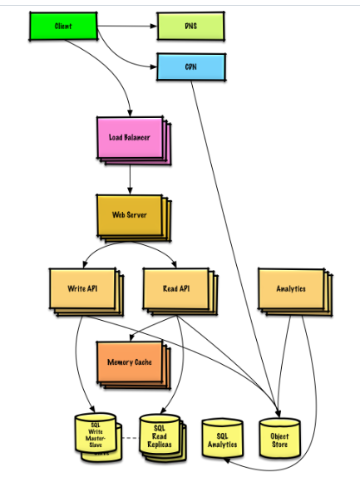

**Twitter timeline:**

* **User** posts a tweet
  + **Service** pushes tweets to followers, sending push notifications and emails
* **User** views the user timeline (activity from the user)
* **User** views the home timeline (activity from people the user is following)
* **User** searches keywords
* **Service** has high availability
* Traffic is not evenly distributed
* Posting a tweet should be fast
  + Fanning out a tweet to all of your followers should be fast, unless you have millions of followers
* 100 million active users
* 500 million tweets per day or 15 billion tweets per month
  + Each tweet averages a fanout of 10 deliveries
  + 5 billion total tweets delivered on fanout per day
  + 150 billion tweets delivered on fanout per month
* 250 billion read requests per month
* 10 billion searches per month
* Twitter is more read heavy than write heavy
  + Optimize for fast reads of tweets
* Ingesting tweets is write heavy
* Size per tweet:
  + tweet_id - 8 bytes
  + user_id - 32 bytes
  + text - 140 bytes
  + media - 10 KB average
  + Total: ~10 KB

### Use case: User posts a tweet

We could store the user's own tweets to populate the user timeline (activity from the user) in a [relational database](https://github.com/donnemartin/system-design-primer#relational-database-management-system-rdbms)

Reading 1 MB sequentially from memory takes about 250 microseconds, while reading from SSD takes 4x and from disk takes 80x longer.

We could store media such as photos or videos on an **Object Store**.

* The **Client** posts a tweet to the **Web Server**, running as a [reverse proxy](https://github.com/donnemartin/system-design-primer#reverse-proxy-web-server)
* The **Web Server** forwards the request to the **Write API** server
* The **Write API** stores the tweet in the user's timeline on a **SQL database**
* The **Write API** contacts the **Fan Out Service**, which does the following:
  + Queries the **User Graph Service** to find the user's followers stored in the **Memory Cache**
  + Stores the tweet in the home timeline of the user's followers in a **Memory Cache**
    - O(n) operation: 1,000 followers = 1,000 lookups and inserts
  + Stores the tweet in the **Search Index Service** to enable fast searching
  + Stores media in the **Object Store**
  + Uses the **Notification Service** to send out push notifications to followers:
    - Uses a **Queue** (not pictured) to asynchronously send out notifications

For internal communications, we could use [Remote Procedure Calls](https://github.com/donnemartin/system-design-primer#remote-procedure-call-rpc)

REST API???????????????

### Use case: User views the home timeline

* The **Client** posts a home timeline request to the **Web Server**
* The **Web Server** forwards the request to the **Read API** server
* The **Read API** server contacts the **Timeline Service**, which does the following:
  + Gets the timeline data stored in the **Memory Cache**, containing tweet ids and user ids - O(1)
  + Queries the **Tweet Info Service** with a [multiget](http://redis.io/commands/mget) to obtain additional info about the tweet ids - O(n)
  + Queries the **User Info Service** with a multiget to obtain additional info about the user ids - O(n)

REST API:

$ curl https://twitter.com/api/v1/home_timeline?user_id=123

**The serviceAPI needs te preprocessing as:**

* The **Search API** contacts the **Search Service**, which does the following:
  + Parses/tokenizes the input query, determining what needs to be searched
    - Removes markup
    - Breaks up the text into terms
    - Fixes typos
    - Normalizes capitalization
    - Converts the query to use boolean operations
  + Queries the **Search Cluster** (ie [Lucene](https://lucene.apache.org/)) for the results:
    - [Scatter gathers](https://github.com/donnemartin/system-design-primer#under-development) each server in the cluster to determine if there are any results for the query
    - Merges, ranks, sorts, and returns the results

REST API:

$ curl https://twitter.com/api/v1/search?query=hello+world

The response would be similar to that of the home timeline, except for tweets matching the given query.

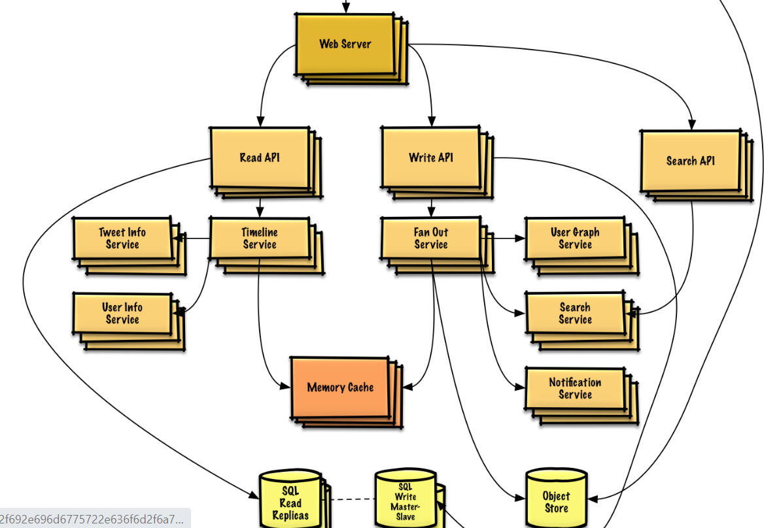

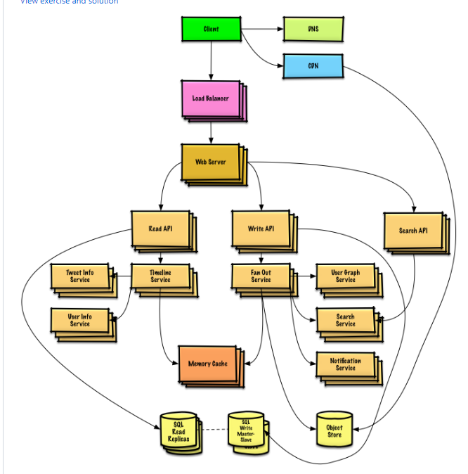

**=================================================================================**

**WebCrawler:**

* **Service** crawls a list of urls:
  + Generates reverse index of words to pages containing the search terms
  + Generates titles and snippets for pages
    - Title and snippets are static, they do not change based on search query

**Inverted Index:**

An inverted index is an index data structure storing a mapping from content, such as words or numbers, to its locations in a document or a set of documents. In simple words, it is a hashmap like data structure that directs you from a word to a document or a web page.

There are two types of inverted indexes: A **record-level inverted index** contains a list of references to documents for each word. A **word-level inverted index** additionally contains the positions of each word within a document. The letter form offers more functionality, but needs more processing power and space to be created.

#### State assumptions

* Traffic is not evenly distributed
  + Some searches are very popular, while others are only executed once
* Support only anonymous users
* Generating search results should be fast
* The web crawler should not get stuck in an infinite loop
  + We get stuck in an infinite loop if the graph contains a cycle
* 1 billion links to crawl
  + Pages need to be crawled regularly to ensure freshness
  + Average refresh rate of about once per week, more frequent for popular sites
    - 4 billion links crawled each month
  + Average stored size per web page: 500 KB
    - For simplicity, count changes the same as new pages
* 100 billion searches per month
* 2 PB of stored page content per month
  + 500 KB per page * 4 billion links crawled per month
  + 72 PB of stored page content in 3 years
* 1,600 write requests per second
* 40,000 search requests per second

### Use case: Service crawls a list of urls

We'll assume we have an initial list of links_to_crawl ranked initially based on overall site popularity. If this is not a reasonable assumption, we can seed the crawler with popular sites that link to outside content such as [Yahoo](https://www.yahoo.com/), [DMOZ](http://www.dmoz.org/), etc.

We'll use a table crawled_links to store processed links and their page signatures.

We could store links_to_crawl and crawled_links in a key-value **NoSQL Database**. **For the ranked links in links_to_crawl, we could use [Redis](https://redis.io/) with sorted sets to maintain a ranking of page links**.

* The **Crawler Service** processes each page link by doing the following in a loop:
  + Takes the top ranked page link to crawl
    - Checks crawled_links in the **NoSQL Database** for an entry with a similar page signature
      * If we have a similar page, reduces the priority of the page link
        + This prevents us from getting into a cycle
        + Continue
      * Else, crawls the link
        + Adds a job to the **Reverse Index Service** queue to generate a [reverse index](https://en.wikipedia.org/wiki/Search_engine_indexing)
        + Adds a job to the **Document Service** queue to generate a static title and snippet
        + Generates the page signature
        + Removes the link from links_to_crawl in the **NoSQL Database**
        + Inserts the page link and signature to crawled_links in the **NoSQL Database**
* **With 1 billion links to crawl, we could use MapReduce to output only entries that have a frequency of 1**

**Detecting duplicate content is more complex. We could generate a signature based on the contents of the page and compare those two signatures for similarity. Some potential algorithms are**[**Jaccard index**](https://en.wikipedia.org/wiki/Jaccard_index)**and**[**cosine similarity**](https://en.wikipedia.org/wiki/Cosine_similarity)**.????**

### Use case: User inputs a search term and sees a list of relevant pages with titles and snippets

* The **Client** sends a request to the **Web Server**, running as a [reverse proxy](https://github.com/donnemartin/system-design-primer#reverse-proxy-web-server)
* The **Web Server** forwards the request to the **Query API** server
* The **Query API** server does the following:
  + Parses the query
    - Removes markup
    - Breaks up the text into terms
    - Fixes typos
    - Normalizes capitalization
    - Converts the query to use boolean operations
  + Uses the **Reverse Index Service** to find documents matching the query
    - The **Reverse Index Service** ranks the matching results and returns the top ones
  + Uses the **Document Service** to return titles and snippets

**Reverse Index??**

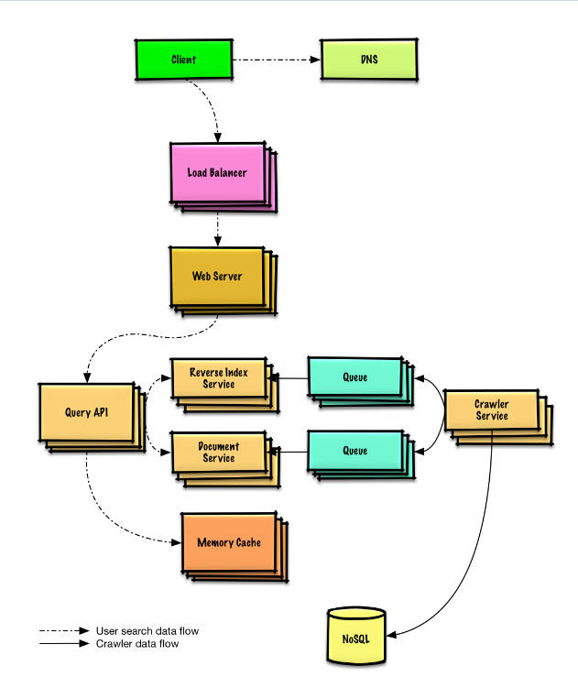

**Mint:**

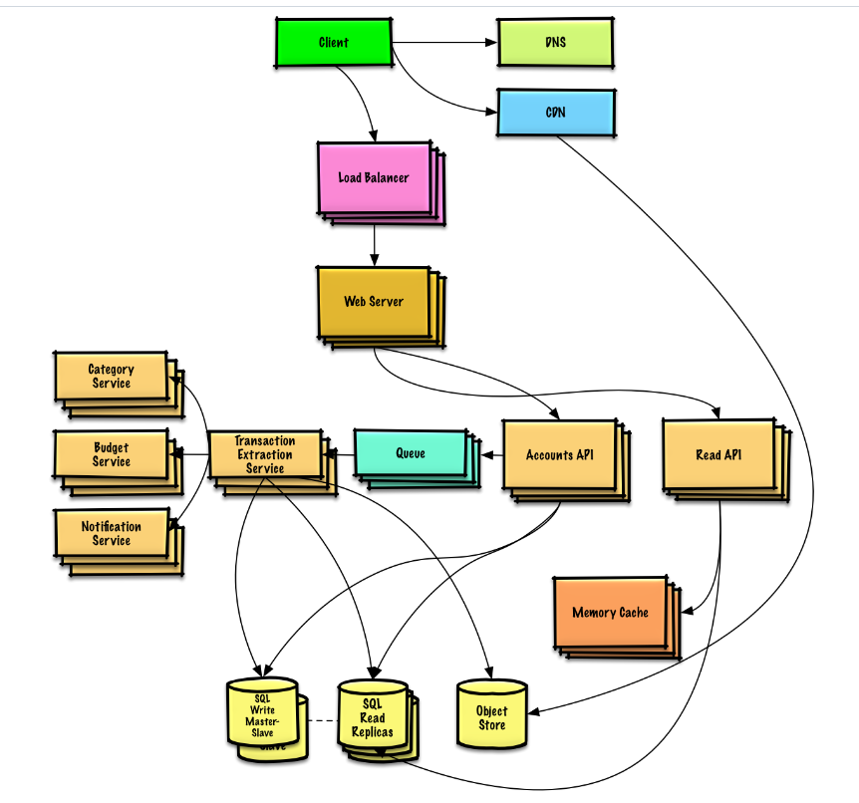

**DS for social n/w:**

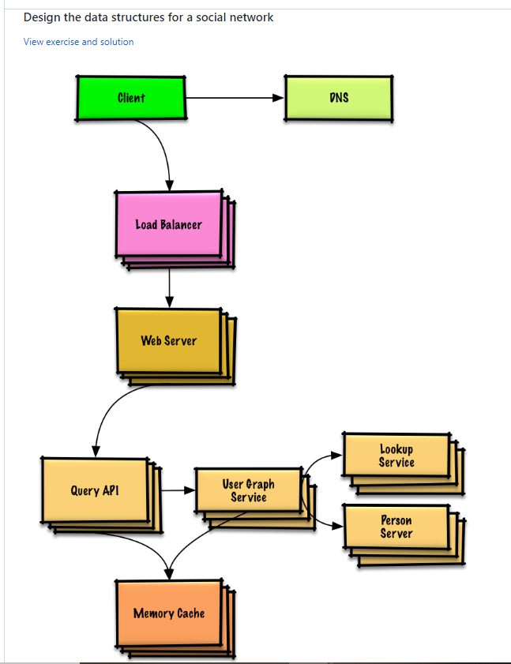

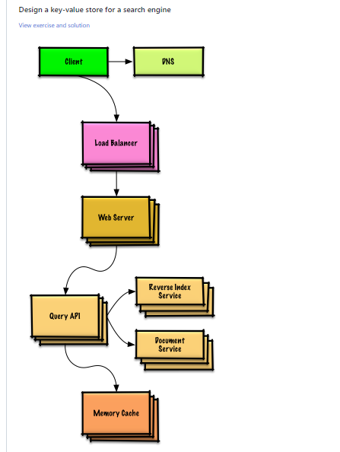

**Amazon Scale:**

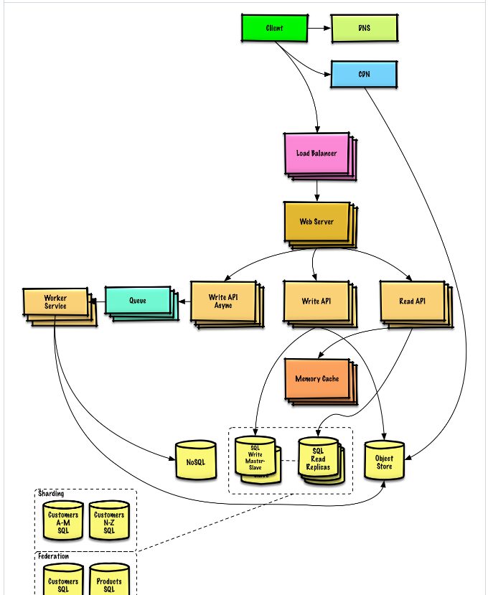

**Amazon sales ranking :**

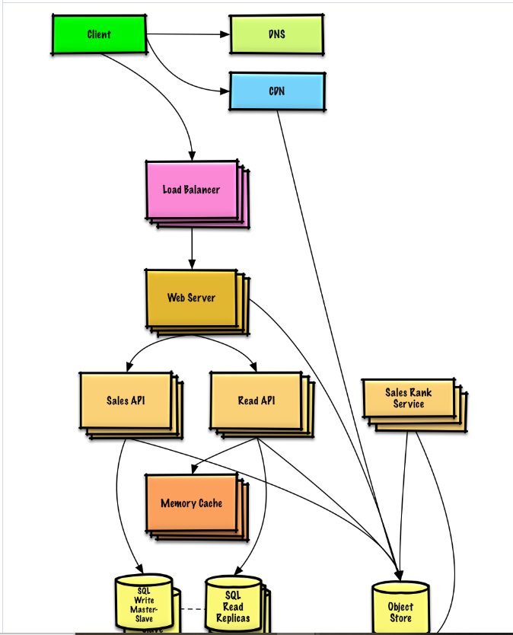



**Youtube:**

Ability to upload a video and watch a video

Different clients;

Mobile apps, web browsers, and smart TV

Diff video resolution, video encryption;

Number of users??

Time spent ???

• Video uploading flow • Video streaming flow

Do ObjectStore have REST API to upload video directly from client??

• Transcoded storage: It is a blob storage that stores transcoded video files. • CDN: Videos are cached in CDN. When you click the play button, a video is streamed from the CDN. • Completion queue: It is a message queue that stores information about video transcoding completion events. • Completion handler: This consists of a list of workers that pull event data from the completion queue and update metadata cache and database. Now that we understand each component individually, let us examine how the video uploading flow works. The flow is broken down into two processes running in parallel. a. Upload the actual video. b. Update video metadata. Metadata contains information about video URL, size, resolution, format, user info, etc.

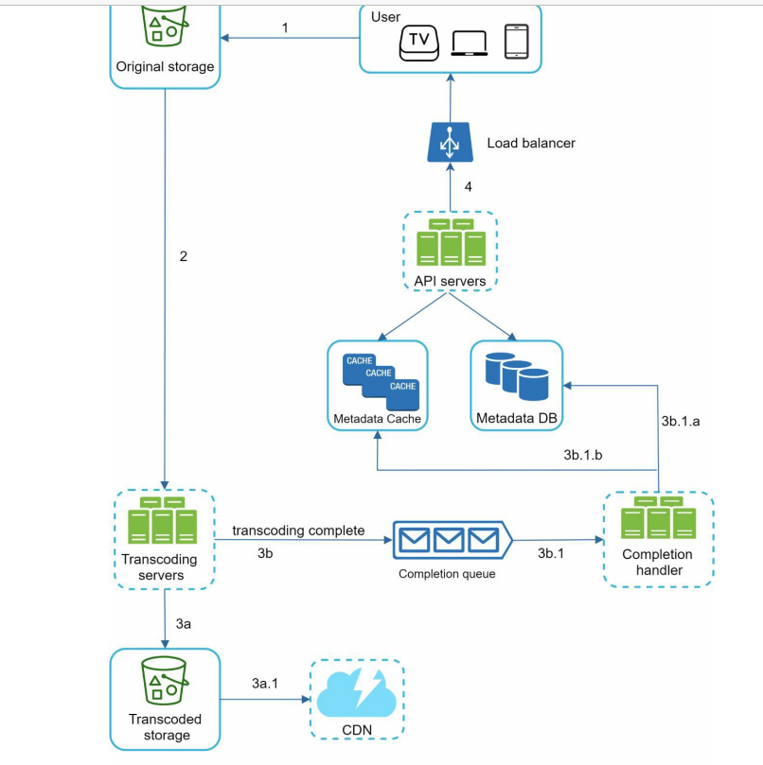

Completion handlers are worker threads that pull events from queue.

Video streaming flow:

streaming protocol. This is a standardized way to control data transfer for video streaming. Popular streaming protocols are: • MPEG–DASH. MPEG stands for “Moving Picture Experts Group” and DASH stands for "Dynamic Adaptive Streaming over HTTP". • Apple HLS. HLS stands for “HTTP Live Streaming”. • Microsoft Smooth Streaming. • Adobe HTTP Dynamic Streaming (HDS)

Video transcoding:

If you want the video to be played smoothly on other devices, the video must be encoded into compatible bitrates and formats. Bitrate is the rate at which bits are processed over time. A higher bitrate generally means higher video quality. High bitrate streams need more processing power and fast internet speed

Many types of encoding formats are available; however, most of them contain two parts: • Container: This is like a basket that contains the video file, audio, and metadata. You can tell the container format by the file extension, such as .avi, .mov, or .mp4. • Codecs: These are compression and decompression algorithms aim to reduce the video size while preserving the video quality. The most used video codecs are H.264, VP9, and HEVC.

Directed acyclic graph (DAG) model

To support different video processing pipelines and maintain high parallelism, it is important to add some level of abstraction and let client programmers define what tasks to execute. For example, Facebook’s streaming video engine uses a directed acyclic graph (DAG) programming model, which defines tasks in stages so they can be executed sequentially or parallelly [8]. In our design, we adopt a similar DAG model to achieve flexibility and parallelism

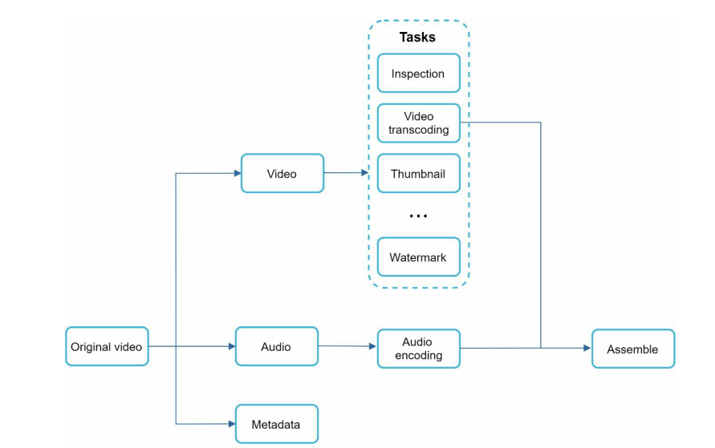

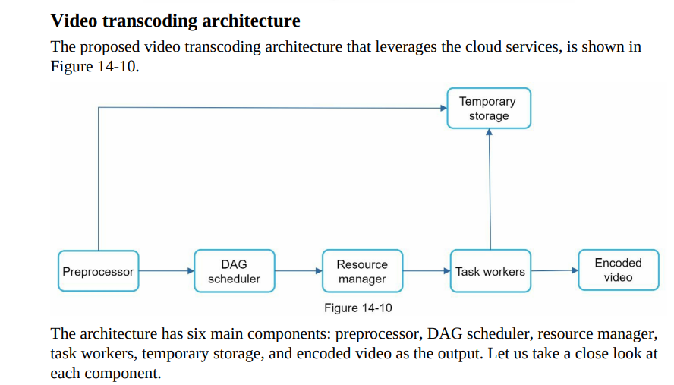

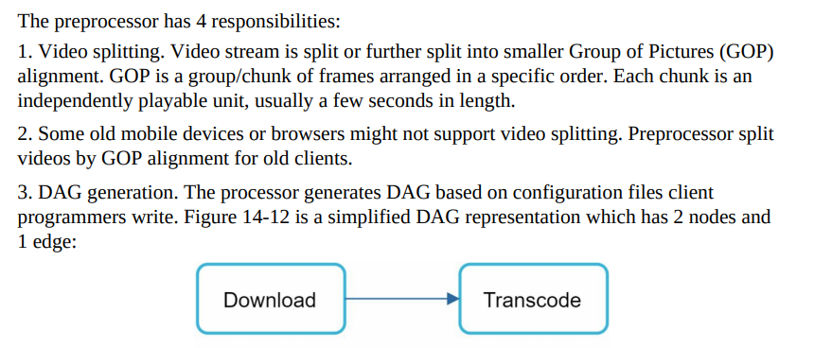

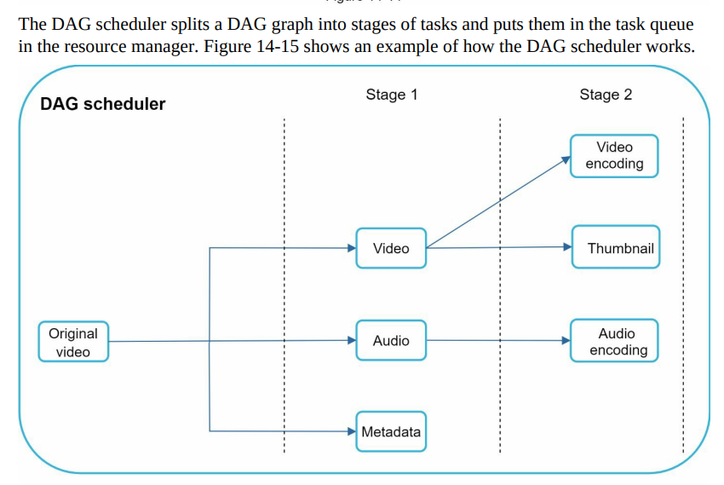

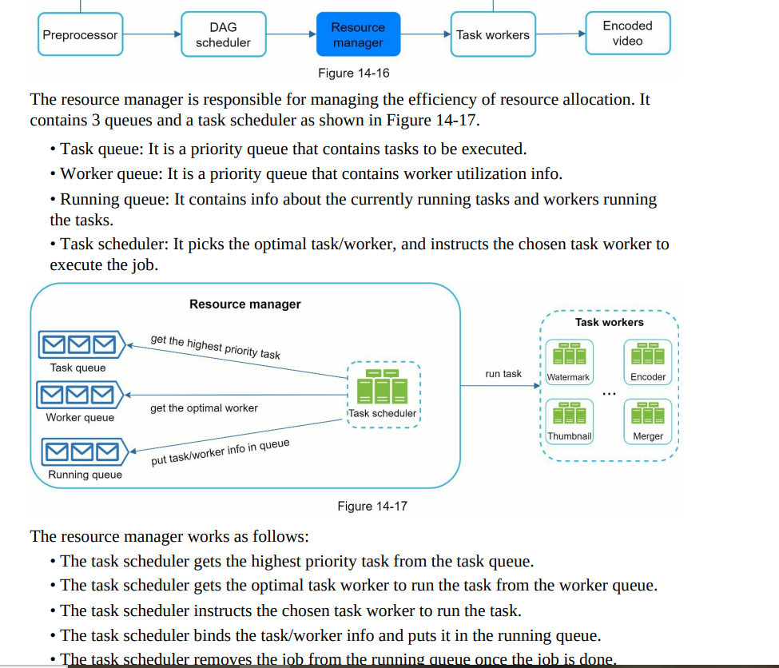

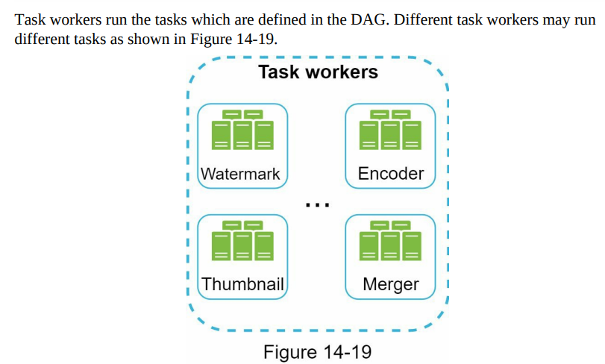

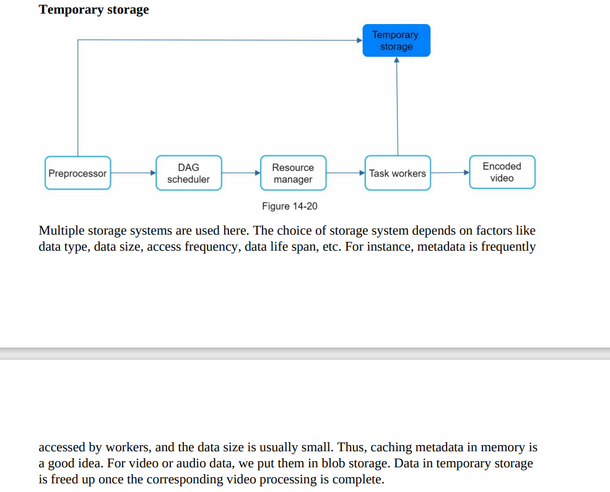

**RATE LIMITER:**

**=====================**

**Rate Limiter:**

**====================**

**+ve**

**1.Prevent Resource Starvation by DoS Attack; by blocking access calls.**

**300/user/60 sec for read**

**2.Reduced cost; by limiting excess calls to paid third part APIs. example???**

**3.prevent serveroverload caued by bot or user misbehaviour.**

**Client Side or ServerSide rate limiter?????**

**here server-side; client-side can be manuplative**

**RL should throttle APIs by either IP address , userID ; configurable???**

**Implement as seperate service OR in app code????????**

**======================**

**High fault tolerance**

**excetionhandling**

**cleAR Message to client.**

**limit accuratley with lowlatency and min footprints**

**Implement RL as middlewre/API Gateway and NOT in API Servers.**

**RL**

**SSL Termination**

**authentication**

**IP Whitelisting**

**serving static content.**

**Algo in RL:**

**token bucket**

**leaking bucket**

**fixed window counter**

**the user and is counter store in REDIS for fast access**

**if reached than 429 error code.**

**save throttle rules in confgi file on disk and Workers freq pull rule from disck to cache**

**Challenges in distributed:**

**1. race condition; thus use sorted sets DS in redis????????**

**2. Syncronizatio; using centralized redis and eventual consistency???????????how reis is used here?**

**Can be applied at APPlication level(layer 7) or using IP Tables(layer 3)**

**NOTIFICATION SYSTEM:**

Service 1 to N: A service can be a micro-service, a cron job, or a distributed system that triggers notification sending events

**Security?**

**Protocal to call queue and third party services????**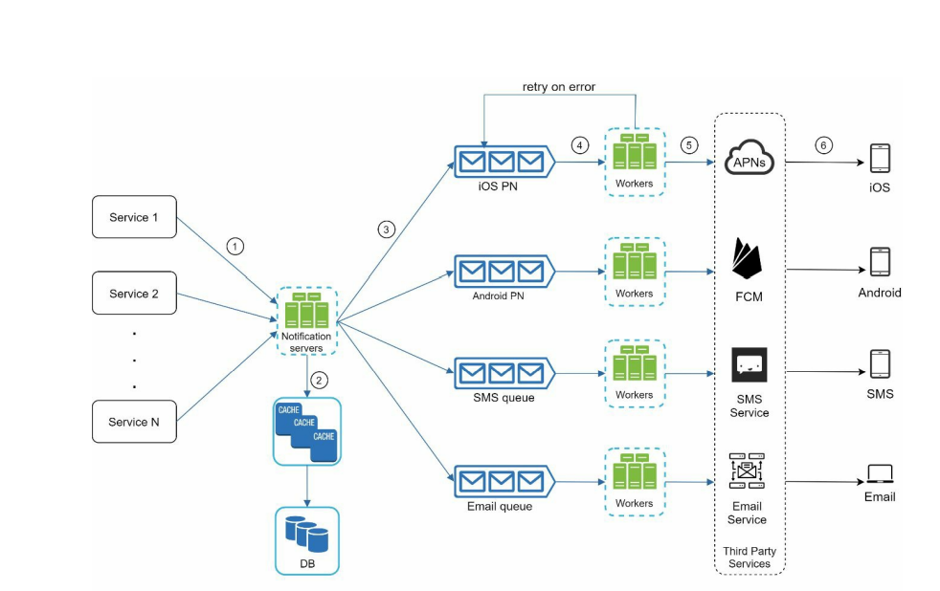

**NotificationLog?????**

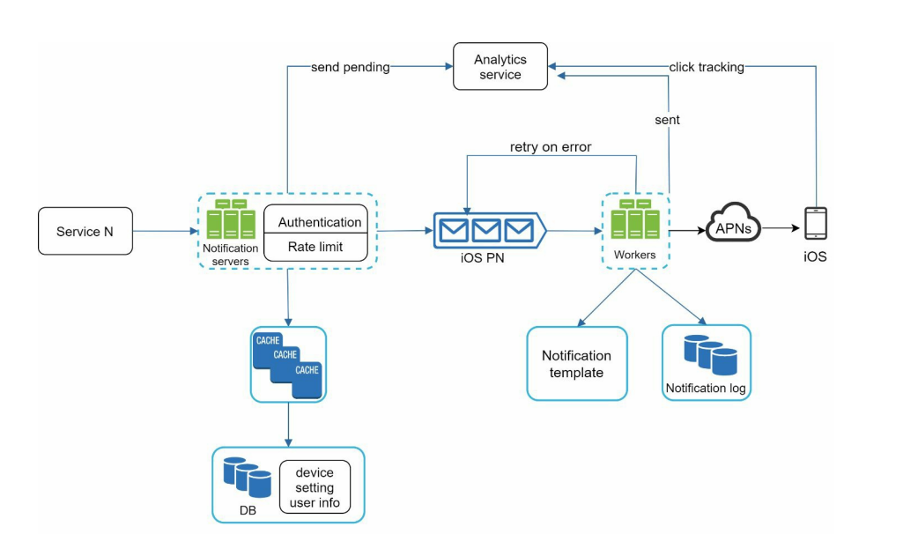

**Stock Exchange System:**

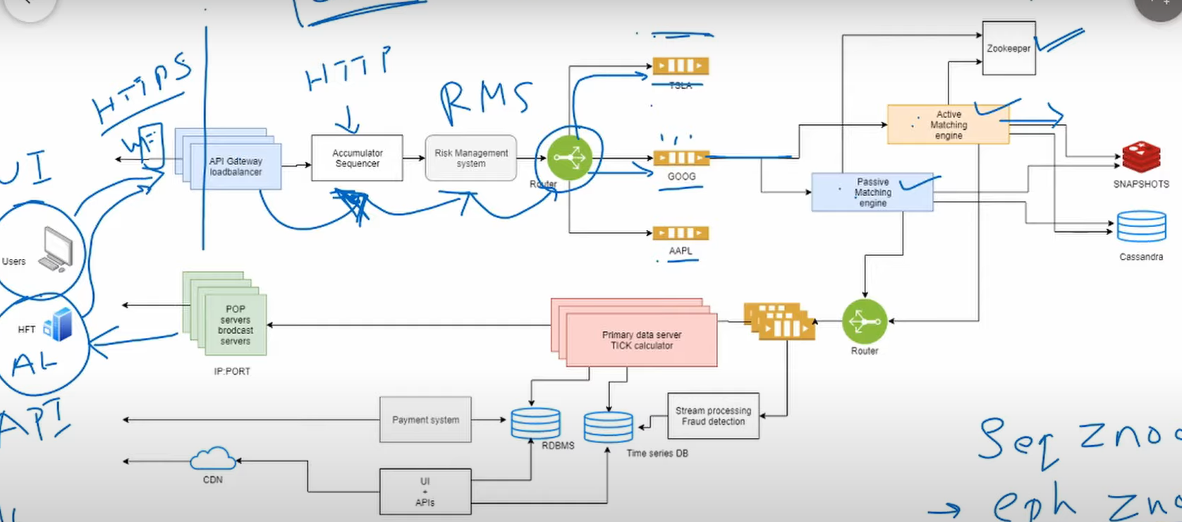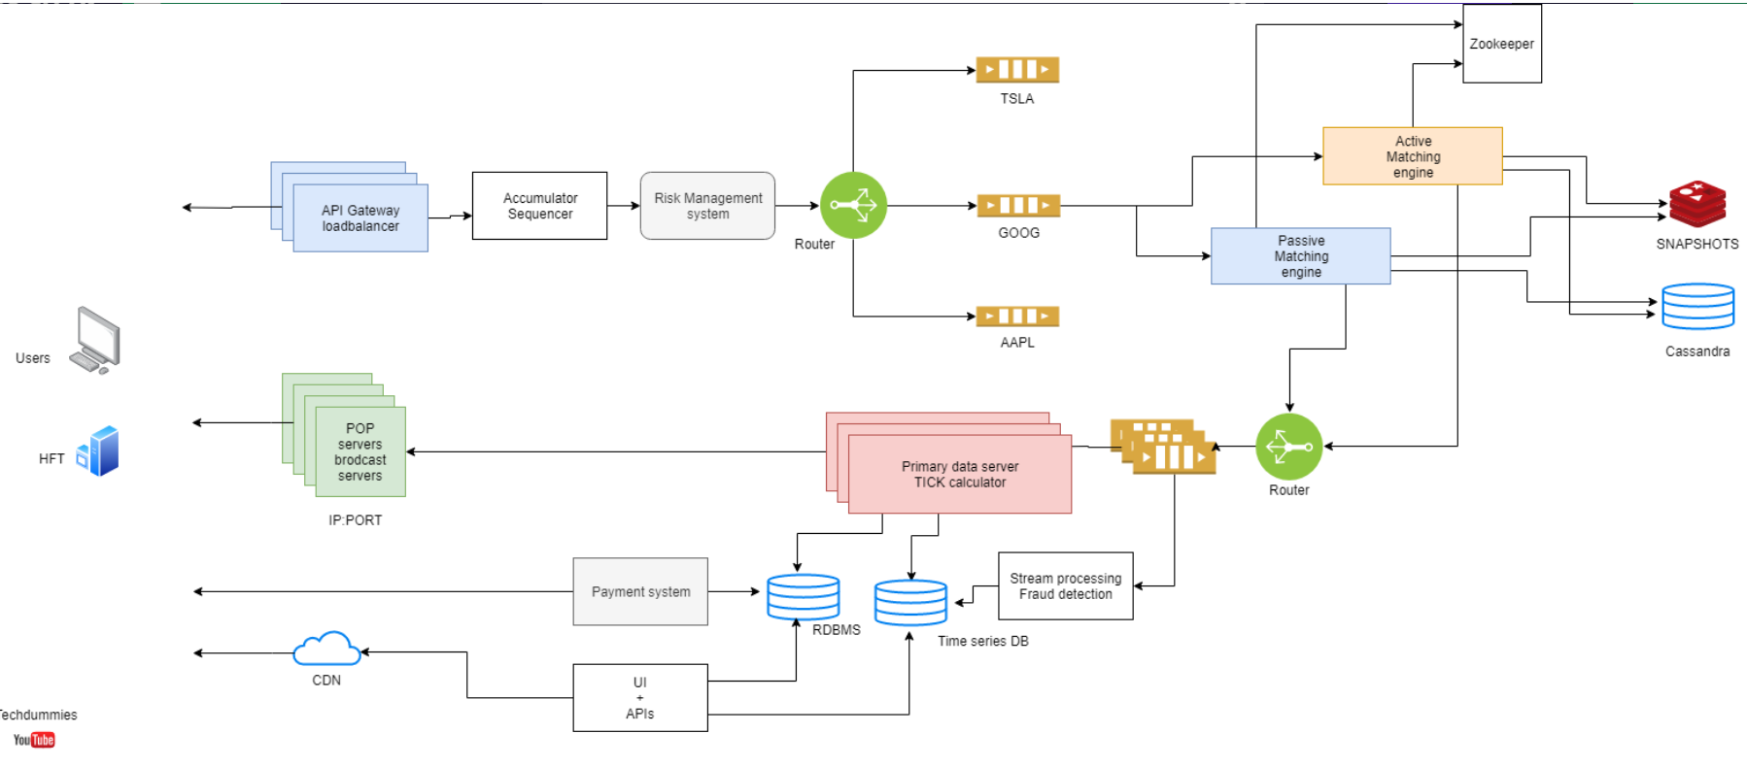

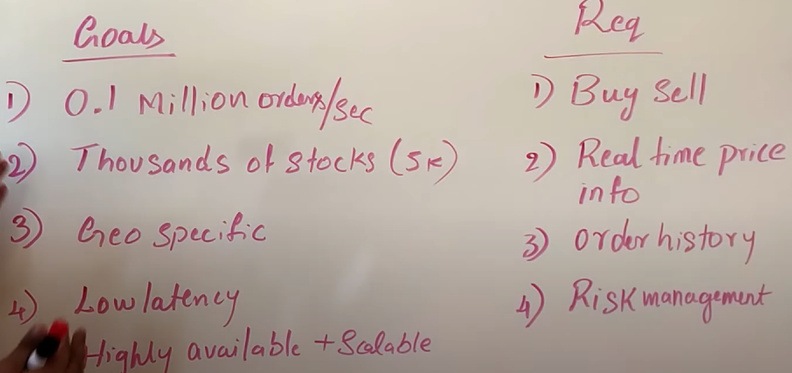

Restrictions:

1. Perform operations in in-memory NOT DS
2. DS used must be serializable

Order: { id,price,quantity,status,metadata}

Accumalator seq; provides unique id not DB as all operations done inmemory

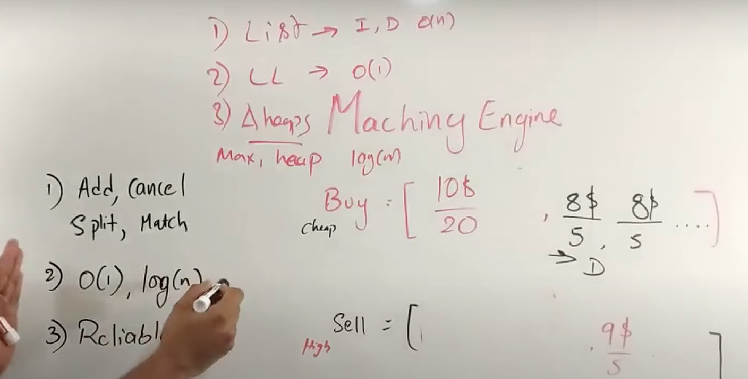

WEB CRAWLER:

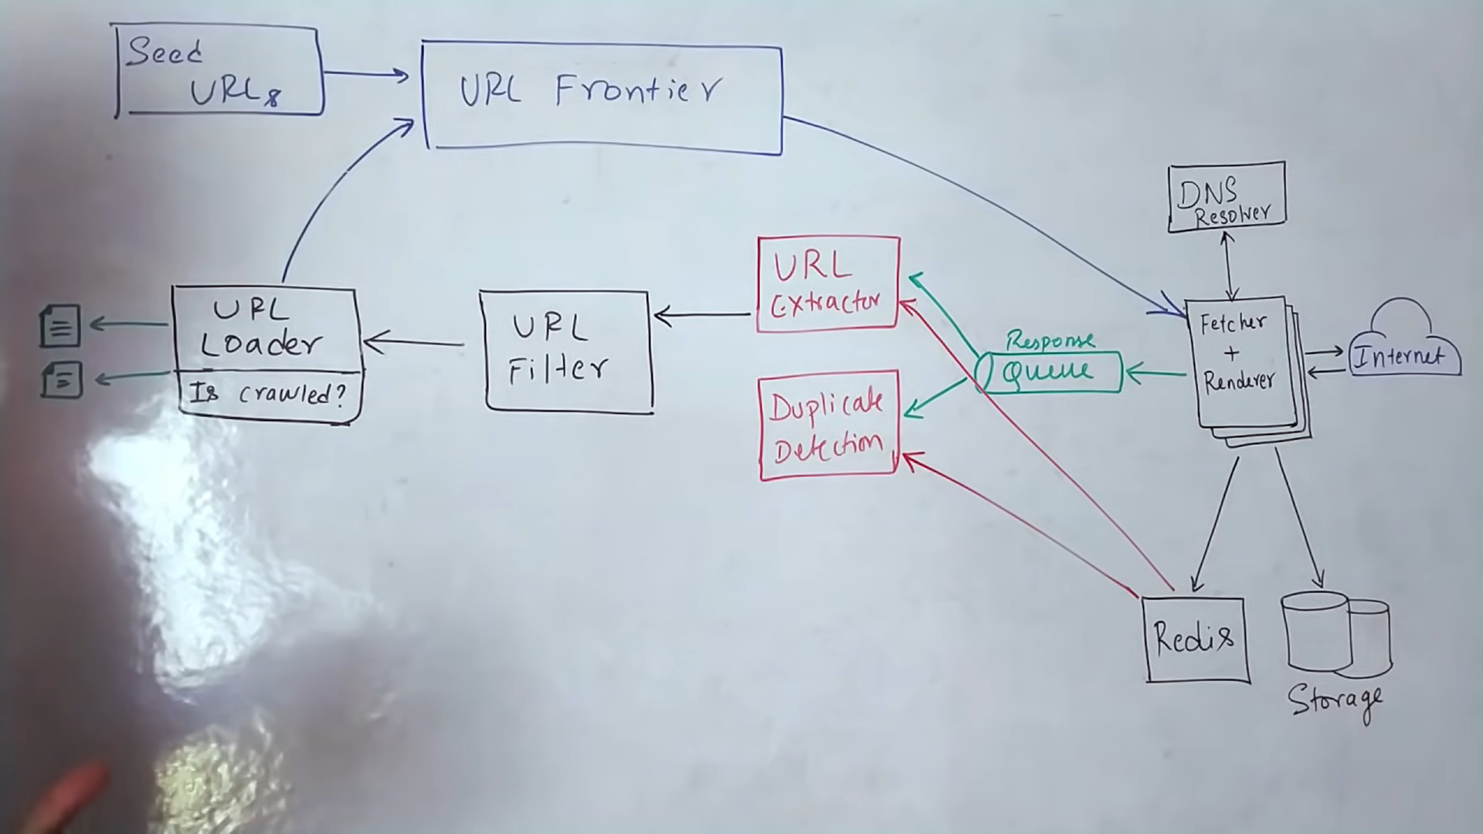

# What is asynchronous processing?

The common pattern for async programming: 1. Callbacks 2. Placeholder style (future, promise and deferred) 3. Queue 4. Signals

CallBack in Asynchronous??

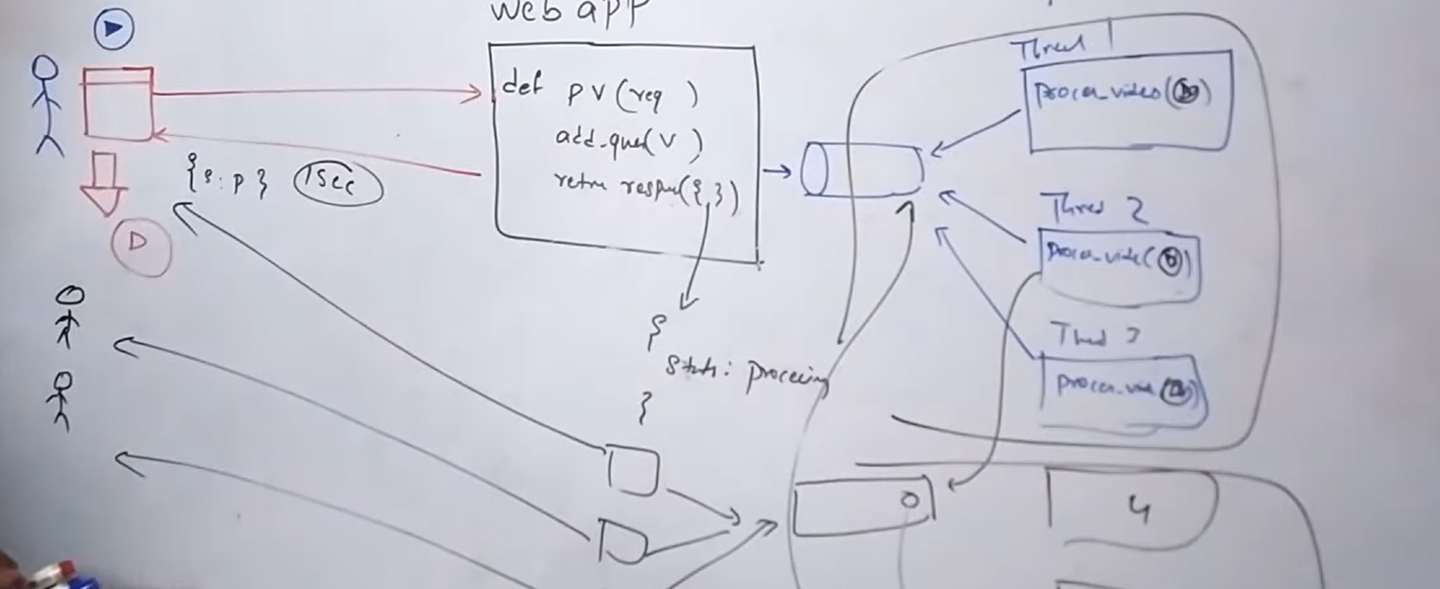

In Sync way; all processing was done in service

Neither user nor service is blocked in asynchronous ;only worker thread is bloked and client needn’t have connection open all time with service

Howver has limitation that only 3 users i.e. 1 user/thread can process.

Similar queue/worker thread pattern is used for sending notification when upload has completed

**Real time streamProcessing**

Spark microbatching as RDD; ensure no data lost if any machne fails

**Continuous operator model.**

Nodes are connected via queue as Kafka and node is an operator.

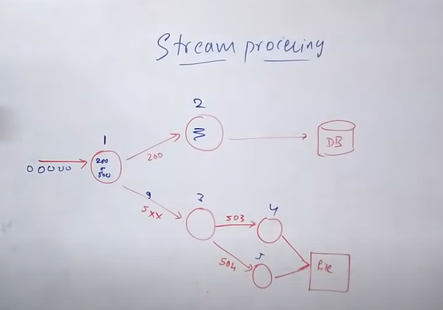

**System Design: Yelp**

Location based services:

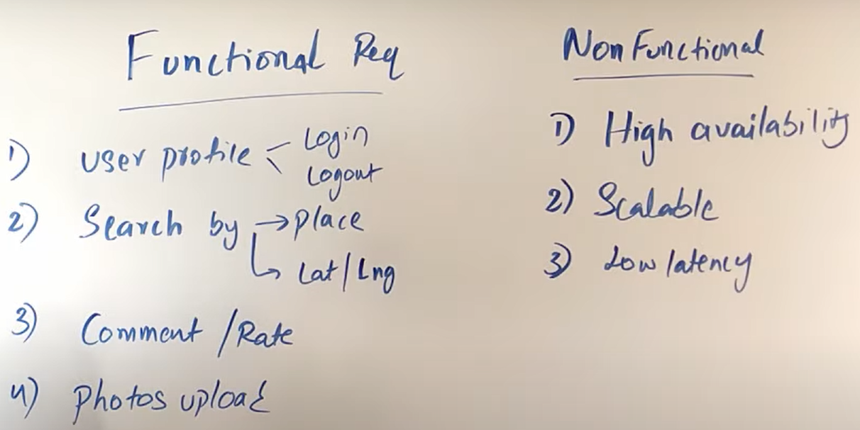

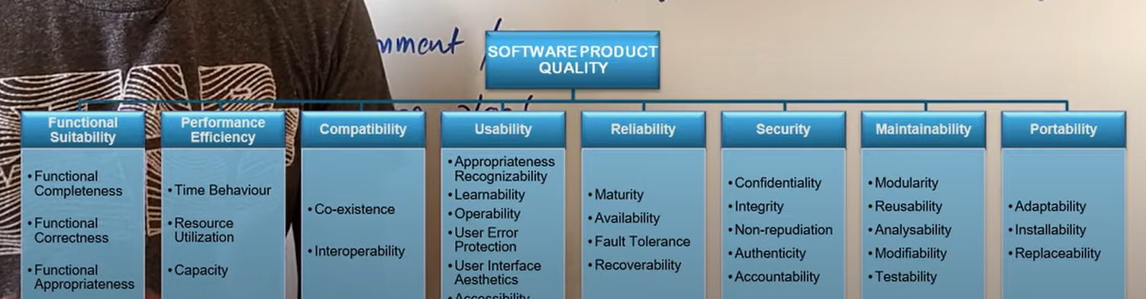

Restriction:

Traffic not same always

What to save:

Name,uuid,lat/log,location

Data need to store increases year on year.

Active Users and total users to find; QPS

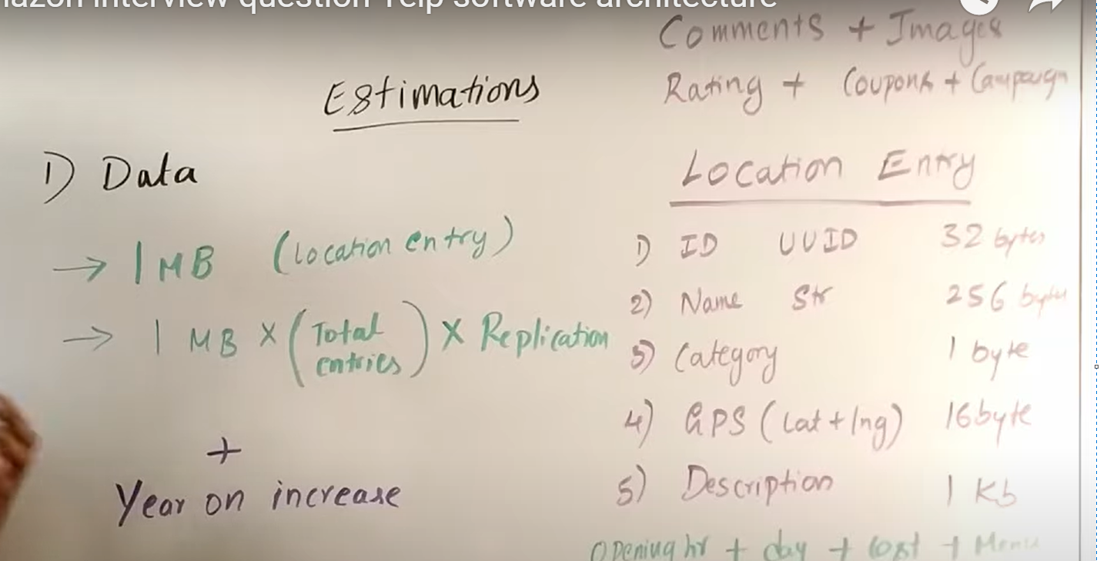

API Design login, logout

Opt for Inconsistency.

MongoDB or DS: decide based on if its columner or document type

ES can be used as primary DB as in ecommerce ; adv over mongoDB is; ES can have log/lat and full text search.

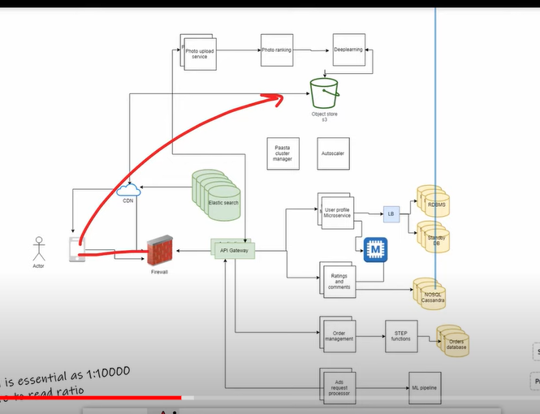

**What is 2P commit?**

Tinder:

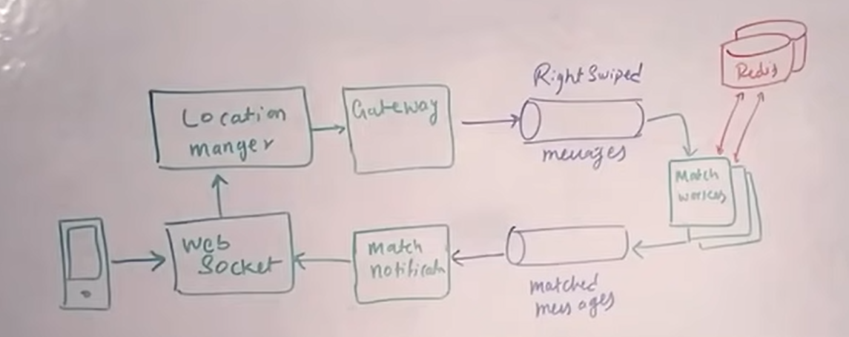

<https://www.youtube.com/watch?v=WEx4HR0FBYQ&list=PLLucmoeZjtMTarjnBcV5qOuAI4lE5ZinV>

**STAR:**

Tell me about a situation where you had to solve a difficult problem

**Situation:**

Machine Learning algo for classification of System Anomaly for PATENT

Didn’t turned for meeting as AdHoc Task

One-to-one meeting: help with communication skill

**Task:**

**Action:**

**Result:** Publish Rating

# Tell me about a time you failed

To address story telling

Master build failed and had to revert as the think went in prod build(**WRONG**)

Make good context to story and make it a big story

**Explain about eGain Communication/ dATAsTRORE FAILED WITH aws CONFIGURATION; ELASTIC ip CHANGED IN aws(LEADER WAVEMAKER DOC ON aws; WENT TO MAINTENANCE WINDOW)**

**Given leadership role and on day of release got failed due to not proper testing**

**Learning: to have though long term view of the role and impact analysis**

**System design:**

How to approach System Design:

Usecase 🡪 Functional - > non functional 🡪 constraints 🡪 bottleneck🡪 HLD 🡪 services(client protocol) 🡪 Load Balancer-🡪 Caching(!00 GB RAM for 500Byte data each request) 🡪 DB(MYSQL vs NOSQL)

* Fail Safe system

Compare Cache with CPU computation tradeOFF

Does cache maintains real time/changing data? Cache only maintains traffic

Consider SOLID PRINCIPLE also in design as ; keep concerned separated

Also, explain the implemented DataStructure Algotithm

Auto Increment Vs features based Sharding???????

1. **Design google Map:**

<https://www.youtube.com/watch?v=lOcqPEOROwQ>

1. **Target audience**

Interviewer: Evaluate how to deal ambiguity

Functional and Non Functional Requirements(**Usecase: Youtube**)

**Classify if:** SQL ,NOSQL(Cassandra),Cache(Redis) or stream(Kafka+Sparak) or batch processing(Hadoop and Map Reduce)

**4 categories:**

**Users/Customers**

Who and How system to be used

All Users, for individual users or Marketing

**Scale(Read and write)**

How many reads/sec, requests/sec

Are traffic spikes expected

**Performance**

Read-to-write delay accepted??

If no delay than no batch option but streaming only

**Expected latency for read queries?**

**Cost**

If dev is costly; got for open source

If maintenance;; go for public cloud domain installation

**Functional Req:**

System behaviour, APIs

Non-Functional:

System qualities as fast, performance, fault tolerance

**NON-Functional:**

**Decise on CAP Theroem :** bwteeen availability and consistency

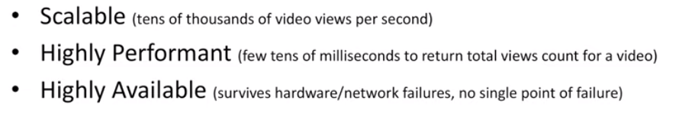

**STEP2:**

Make high level components and start explaining and drive conversation.

**Step1:** Start with data Model

**Compare the two approached for the persistence:**

**In fig:** First approach is stream processing and Later is Batch Processing

**(ASK INTERVIWER FOR APPROACH)**

**Discuss Both the approaches:**

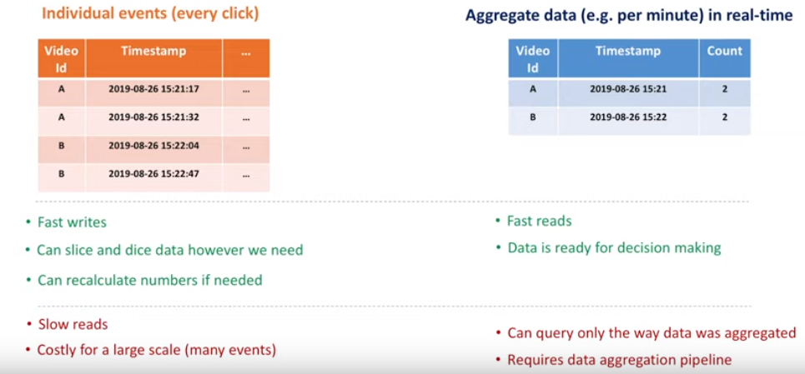

**Discuss Trade OFFs in BOTH Approaches:**

**Step2: Where to store Data**

Evaluate both SQL and NOSQL

Compare for scalability, availability

**Scale for both read/write**

* **Not to loose data if hardware failure**
* **Strong consistency and tradeOffs**
* **Data security**
* **Recover data in outage**
* **Extensible for data model change in future**
* **Cost**
* **On Premises and cloud data centers**

**For MSQL:**

Database sharding ? how it works

Maintain the proxy server/Load balancer

Shard Proxy before Database:

How shard proxy helps??

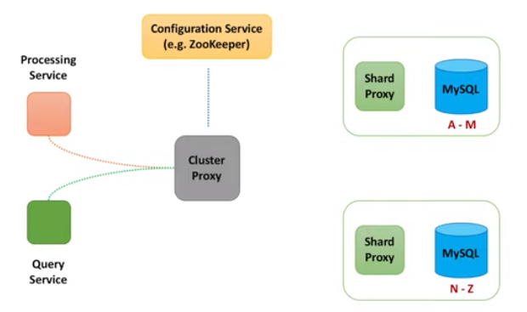

Thus attains scalabilty:

Q: **how to attain availability??**

What if DB shard dies?

Replication

Done synchronously OR unSyncronously

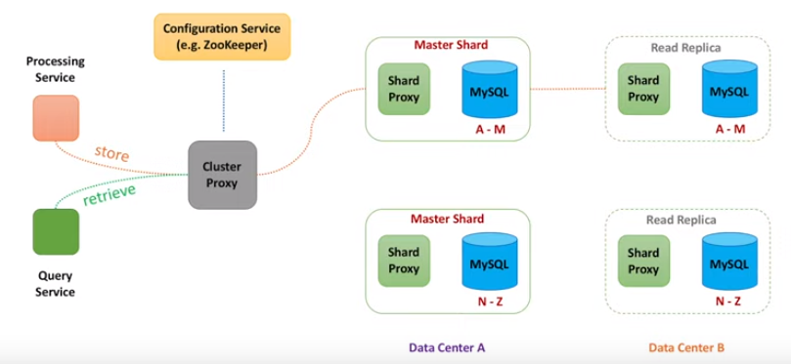

**Alternately, for NO SQL as Cassandra**

**Gossip Protocol;** used to sync data across multiple Nodes

*In SQL approach ; only proxy shard knew about all nodes BUT in NO SQL each node knows about other Nodes*

**Node can be chosen based on Round Robin algo or node closed to client in term of netword distance**

**Uses consistent hashing:**

**Starting node is coordinator Node**

**Has Quorum read and quoram wrte approach**

There might be the stale data as one not misses thus **; eventual Consistency**

**For Non Functional req: Availabilty dominates consistency**

**As Data is replicated Asyncronously and inconsistency is temporary**

**Step 3: How to store Data**

**Report Building:**

Need join across if using RDBMS:

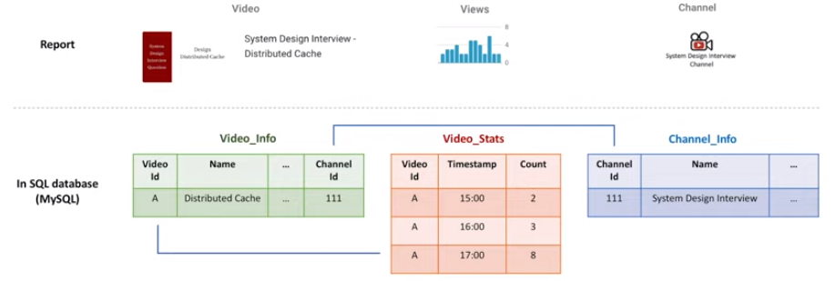

Advantage: Normalization hence, less data redundancy

**In case of NO SQL:**

Think as query

Add column for every other transaction / hour

Prefer Cassandra as; its best for Real time analysis

**Compare which NOSQL needed for which purpose?**

Types of NOSQL

* Column
* Doc
* Key-value
* Graph

**Data Processing:**

ProcessingService:

Write requirements on White Board:

Scalable == portioning

Reliable == replica and checkpoint

Fast == in memory

**Data Aggregation basics:**

Prefer Second option: In-Memory Counter

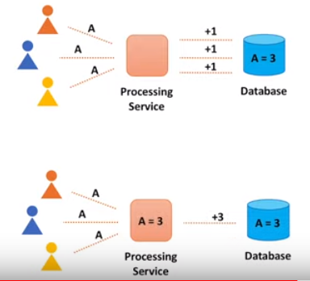

Push the changes from processService or PULL?

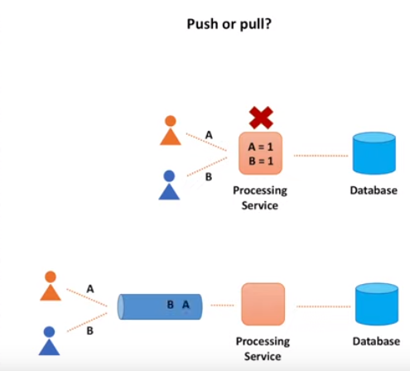

**CheckPointing:**

In StreamData Processing:

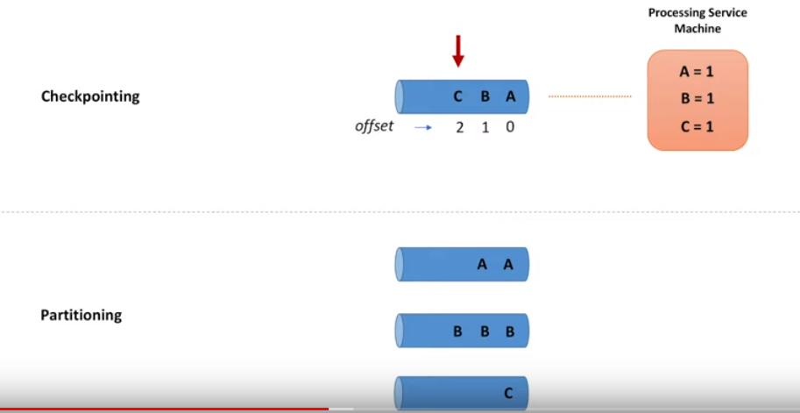

Uses Hashing to pick a queue to parse the message

**ThroughPut Vs MultipleThreads???**

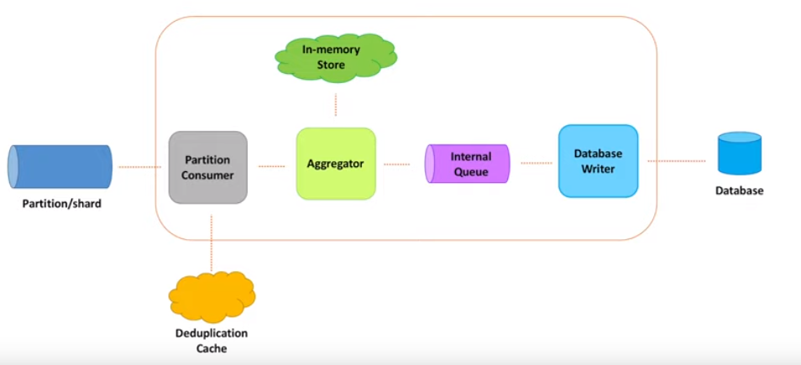

Use of Dead-letter Queue:

Database in same machine where processService is residing: called Embedded DB; thus lessens the need for remote call

**StateManagement for Objects stored in In-Memory: How to deal iff machine fails?**

**Thus use Store data.**

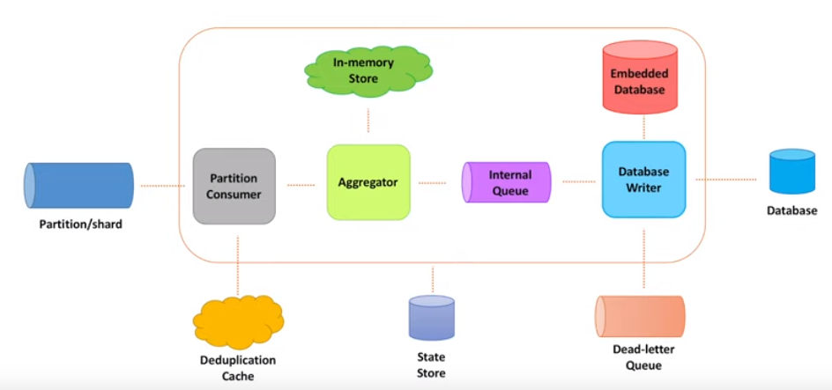

**Data Ingestion:**

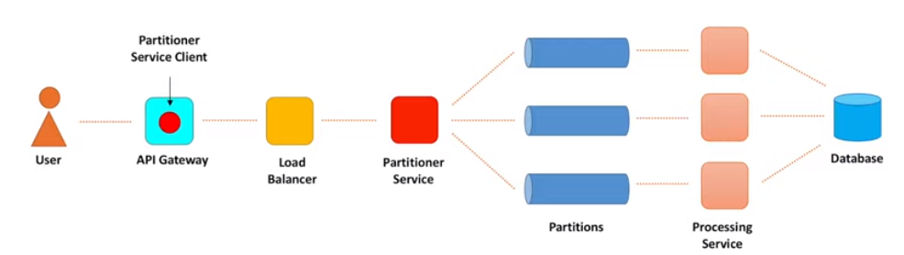

Ingestion path component:

**Blocking I/O Vs Non-Blocking I/O**

The thread create a connection and blocks the socket as well

One thread/connection??

Rate Limiter: Important here

Non-Blocking Systems have: High ThroughPut

Than why so many Blocking I/O system??

Tracking is problematic in Non-Blocking BUT Blocking I/O has thread stack to track progress

And also Unefficient as makes system too huge and complex

**Buffering vs Batching::???**

**Timeouts:**

Connection timeout: client willing to wait for connection to get established; time is usually too low < 3 ms

Request Timeout: when request process takes time; need to evaluate latency %tile(as 1 out of 1000 req. will get timeout); option is to Re-Try

**Exponential Backoff time and jitter: value to fix min. time between re-tries**

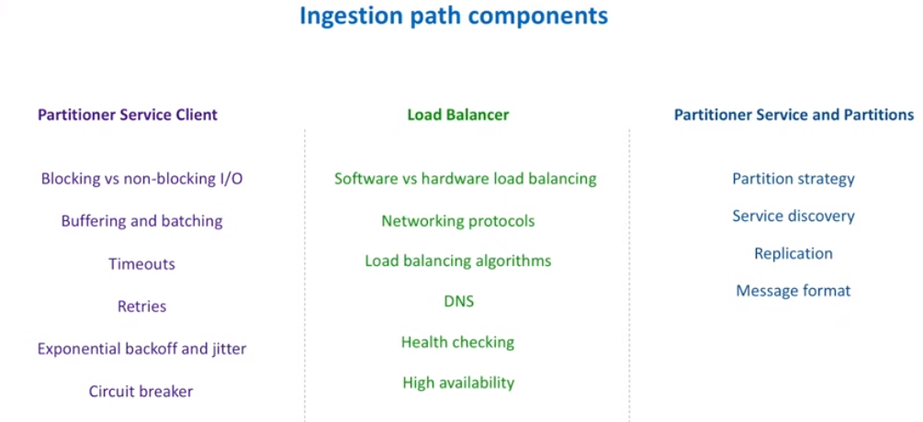

**DISTRIBUTED CACHE:**

**SOLID PRINCIPLE:**

**Single responsibility:**

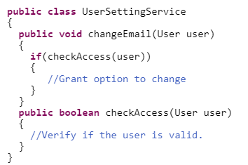

**Open and closed:**

Code to interface; so no if-else rather extend to create new class instead

**Interface segregation Principle:**

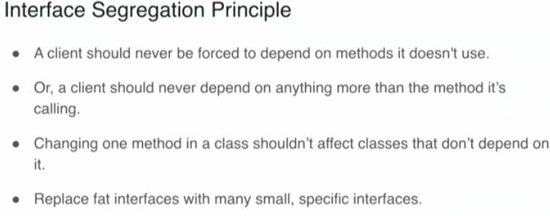

Unnessaray forced implementation

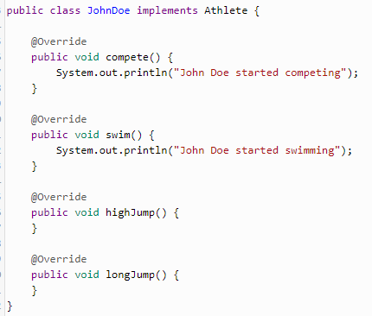

Dependency Inversion

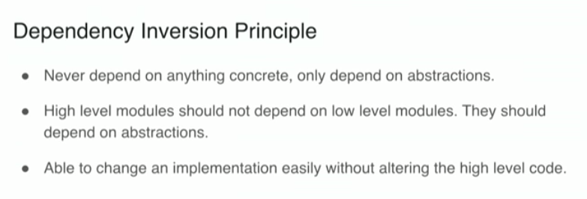

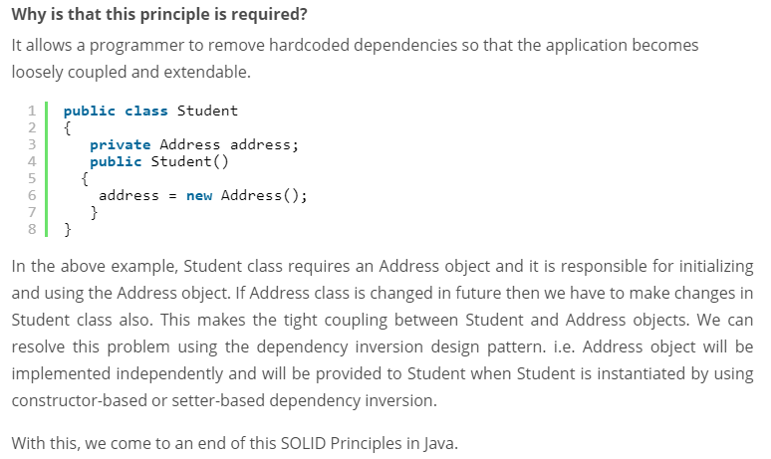

**API Gateway:**

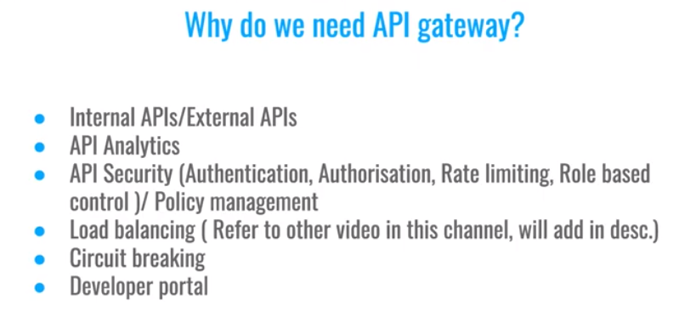

**Reverse Proxy:**

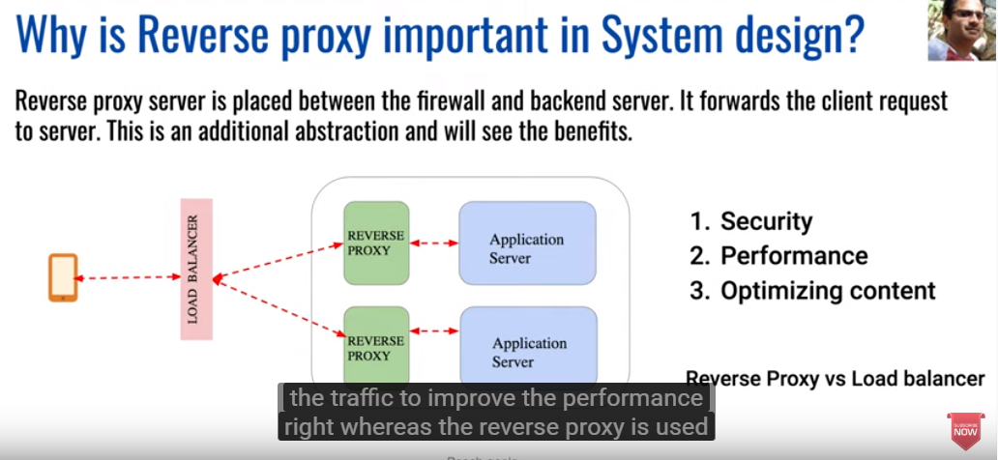

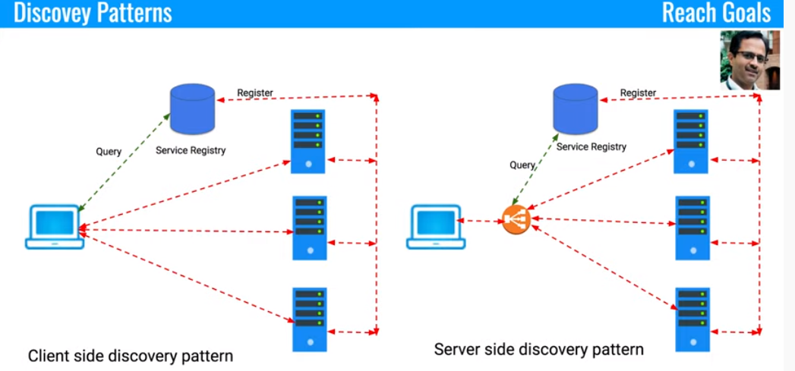

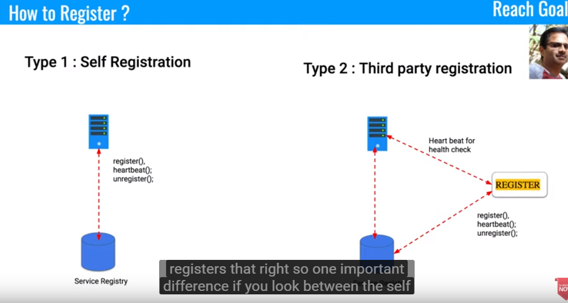

**HTTP Polling:**

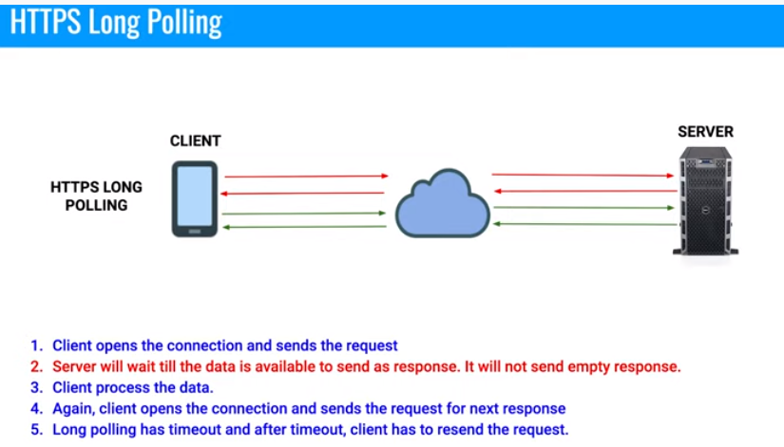

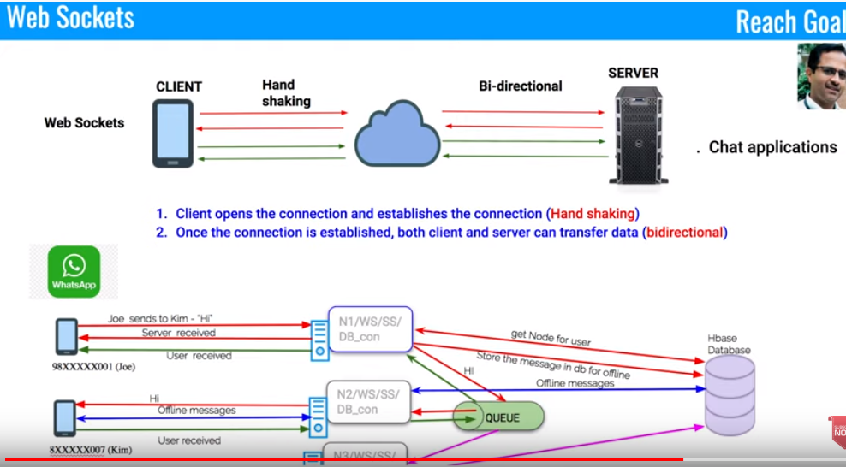

**DataBase Sharding:**

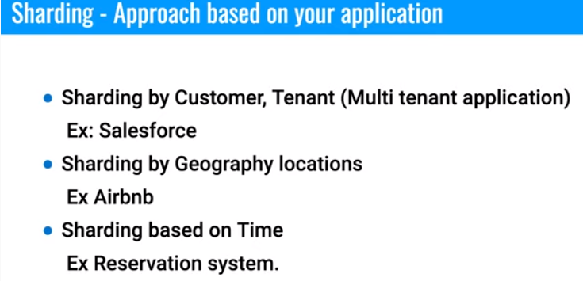

**SOLID PRINCIPLE:**

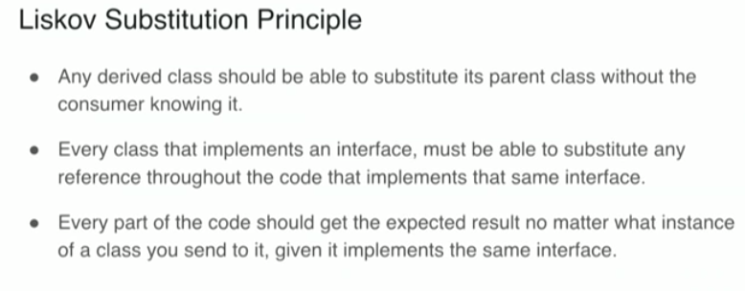

**Circuit Breakers:**

**Design whatssup:**

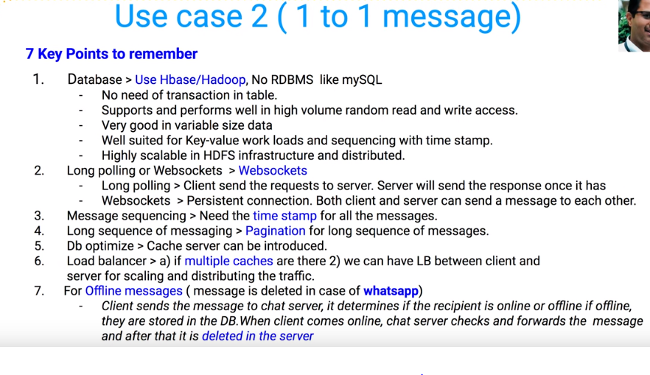

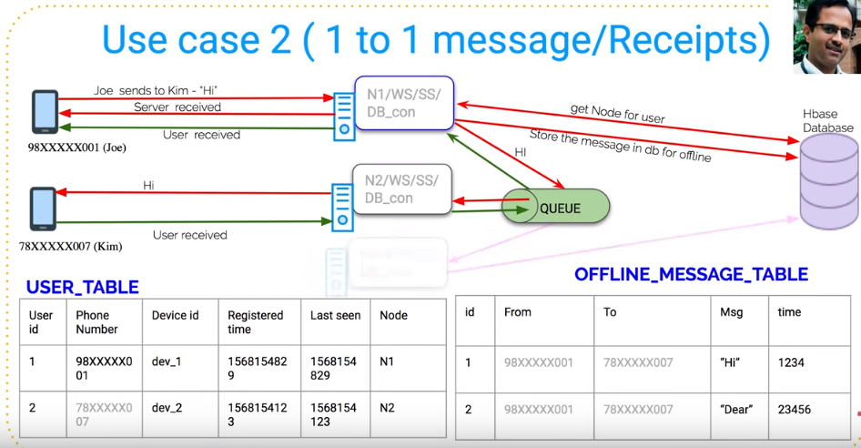

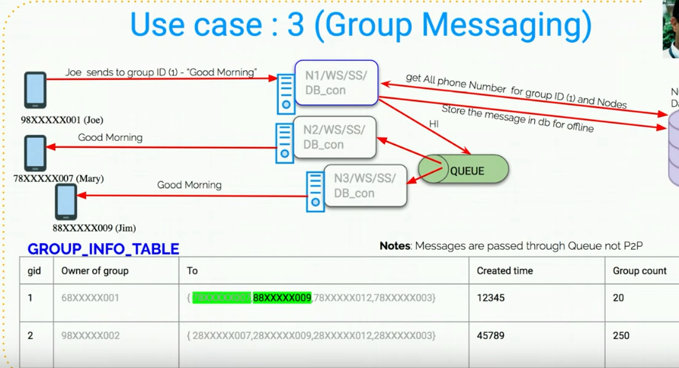

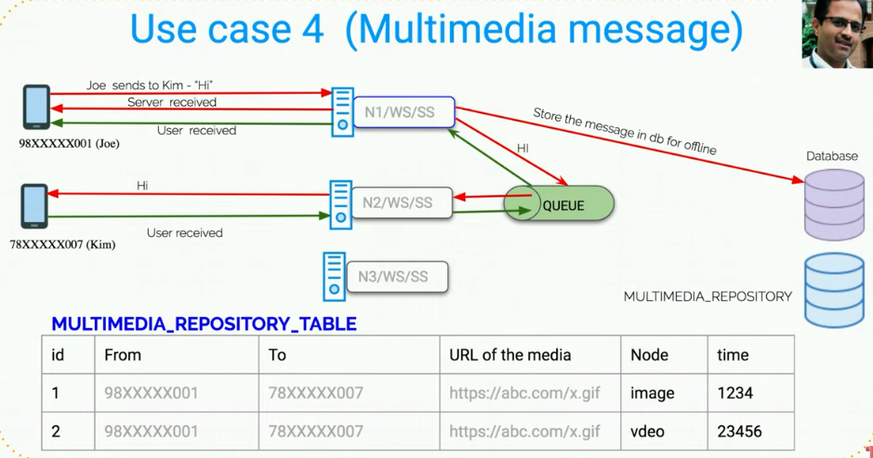

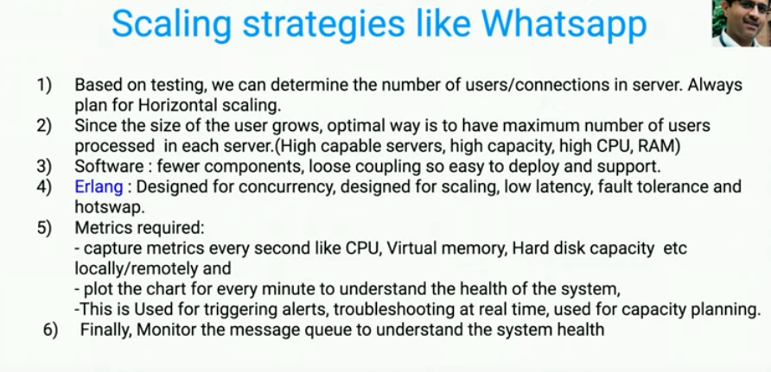

**Twitter System Design:**

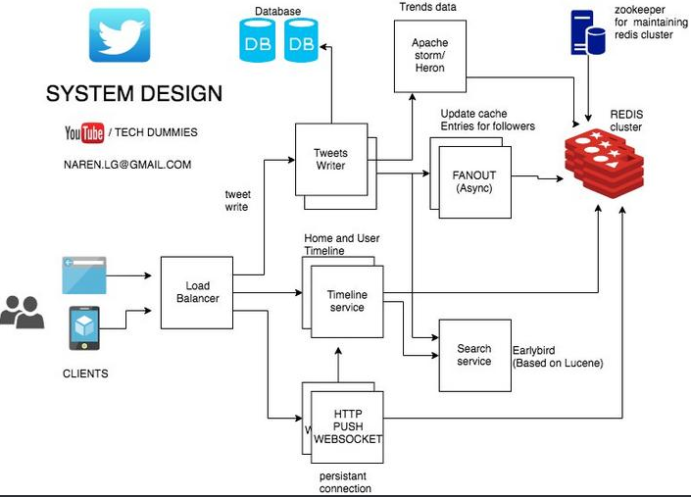

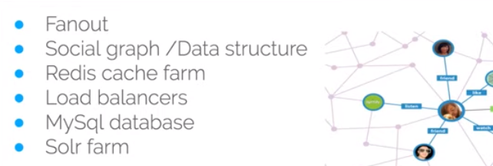

**Solr Farm or Elastic Search**

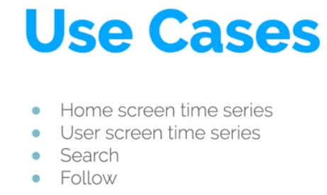

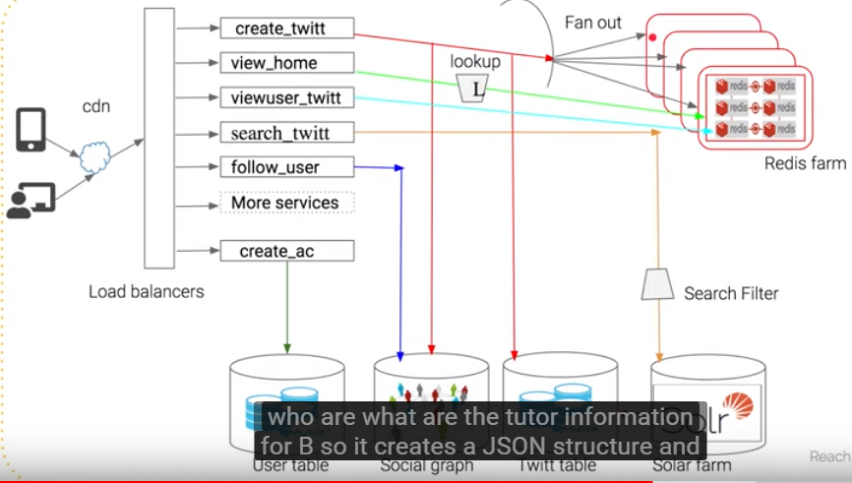

**Features:**

* **Tweet**
* **Timeline : Home timeline / User timeline / Search Timeline**
* **Trends**

Read heavy

**Eventual consistency**: consistency not major factor

Storage cost??

User Table | Tweets Table | Follower Table

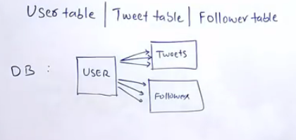

Caching layer needed for a read heavy Twitter

In redis the structure to be as :

User_ID : USER_treet IDS[1,2,3………….] as list

Tweet_ID: User_id

BottleNeck is multiple DB queries: Alternatively: NoSQL/Nodes

Data need to create the Hometimeline? Using **FANOUT** to push the tweet made by person to his followers into there individual Home Timeline Cache

Get the tweets from the Cache rather than from Database based on User ID

how much latency is acceptable in database query?

How much fast does a Cache makes the operation as compared to DB query?

Also maintain HomeTimeLine in Redis Cache

Do we need to precompile the HT and UT for user who haven’t logged to their twitter account?

No,We can avoid the processing

**#Trends:**

*Streaming????*

Stream processing Framwork as **Apache Storm**

**Or Kakfa**

ZooKeeper??

Use cache against distributed DB / nodes using FANOUT

Redis a cache db??

API are exposed form Redis to be consumed further

**In memory database?? How Redis maintains persistence of data when machine crashes**

Trends: volume of data/ **stream processing: storm or kafka**

Validation

Indexinf for seach/ lucene

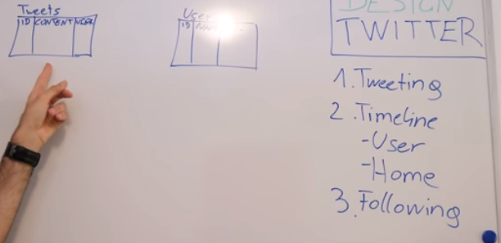

**Sending tweets**

**Eventual consistency:**

**URL Shortener:**

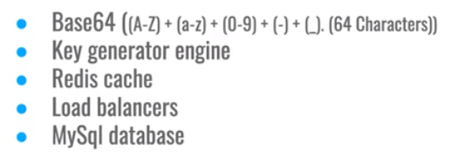



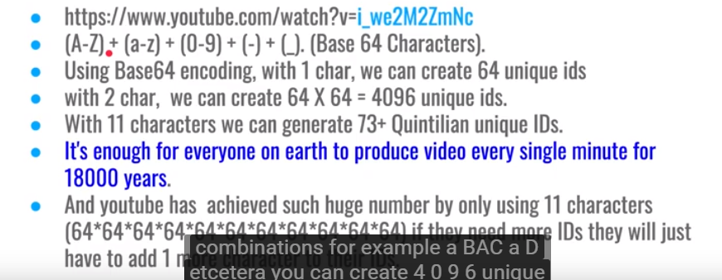

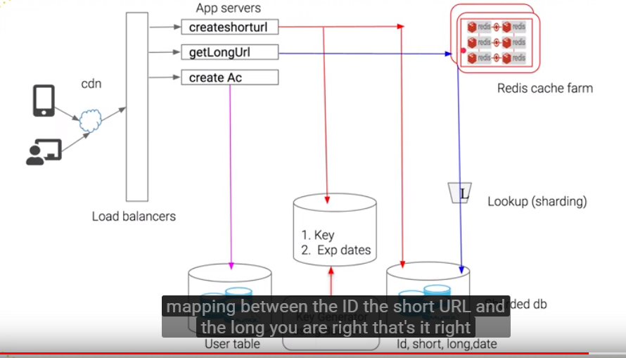

**DataBase sharding: Based on expiration date**

**Tiny URL**

1. Load of requests
2. Character of bytes for short url
3. 1 million user / month
4. Mapping between Actual Url and tiny URL
5. Prequeisite:
6. The size of data to be inserted into Database:
7. Called :DataCapacity Model

**Details to persist in database:**

**LongURL | ShortURL | created time(epoch) | expiry at**

**The above is entry of data per URL Shortener**

Now, to decide the database: DBMS or NOSQL need to understand the number of read/ write operations

The TinyURL have a ***domain.name/uniqueCode***

The Unique Code is generated:

Base 62 / Md5 Hash

MD5 takes string as input and might give outputs with collision

So use Base 62 and Base 10

As Base 62 has values from A_ Z , a-z and 0-9

Hence, 62 pow 7 will give 3.5 trillion combinations of UniqueIds

**Database:**

RDBMS: ACID but not scalable as per month 30 Million read/write

NO SQL: Highly Available, scalable BUT *Eventual Consistency*

Use base 62 libraray to convert ramdomnumber to base 62

<https://www.youtube.com/watch?v=bUHFg8CZFws>

BEHAVIROL QUESTIONS:

<https://leetcode.com/discuss/interview-experience/468811/Amazon-or-SDE2-or-Seattle-or-Dec-2019-Offer>

Tell me about a time when you had to work on something after you have delivered it  
How did you handle a tight deadline?  
What aspects would you improve if you had to do it again?  
Tell me about a time you had to handle conflict  
Tell me about a time you disagreed with your team  
Tell me about a time when you went out of your way in your company

<https://leetcode.com/problems/group-anagrams/>

<https://github.com/donnemartin/system-design-primer>

**>>>>>>>>>>>>>>>>>>>>>>>>**

**LEETCODE DESIGN QUESTIONS:**

Design a system that checks the health of 10,000 nodes. Each of 10,000 modes have an API exposed that you have to call and check the health. This API takes 1-5 seconds to respond. There is UI which tells which nodes are healthy OR not healthy. Your system should provide API for this UI. This UI refreshes every 10 mins. So, every 10 mins your system should be able to update data about those 10,000 nodes